**DUY TAN UNIVERSITY**



**RENTING HELPER -**

**A SUPPORT SYSTEM FOR**

**FINDING HOUSE FOR RENT ON ANDROID OS**

# 🙠🖎🕮✍🙢

**PROPOSAL DOCUMENT**

**TEAM MEMBERS**

1. **NGUYEN LUONG HOANG - 1560**
2. **NGUYEN NGOC VU - 1579**
3. **HUA THI THONG - 6419**
4. **NGUYEN DINH THI NGOC DIEP - 1558**
5. **TRAN VAN THANH - 1571**

**Da Nang, Feb - 2018**

|  |  |  |  |  |
| --- | --- | --- | --- | --- |
| **PROJECT INFORMATION** | | | | |
| **Project Acronym** | RH | | | |
| **Project Title** | Renting helper - a support system for finding house for rent on Android OS | | | |
| **Start Date** | 01– Feb – 2018 | **End Date** | 15 – Mar – 2018 | |
| **Lead Institution** | Department Of Information Technology, Duy Tan University | | | |
| **Project Mentor** | Thi S. T. TRINH  Email: trinhsutruongthi@gmail.com  Phone: 0905.723.278 | | | |
| **Product Owner & Contact Detail** | Diep D. T. N. NGUYEN  Email: diep.nguyendtngoc@gmail.com  Phone: 0905.517.760 | | | |
| **Partner Organization** | Duy Tan University | | | |
| **Project Manager &Scrum Master** | Hoang L. NGUYEN | luonghoangdn92@gmail.com | | 0934.799.890 |
| **Team Members** | Vu N. NGUYEN | nnvu92@gmail.com | | 0906.351.761 |
| Thong T. HUA | huathithong93@gmail.com | | 01683.698.807 |
| Thanh V. TRAN | tranvanthanh217@gmail.com | | 01647.187.783 |
| Diep D. T. N. NGUYEN | diep.nguyendtngoc@gmail.com | | 0905.517.760 |

|  |  |  |  |
| --- | --- | --- | --- |
| **DOCUMENT NAME** | | | |
| **Document Title** | Proposal Document | | |
| **Author(s)** | Diep D. T. N. NGUYEN | | |
| **Role** | Team member | | |
| **Date** | 05-Feb-2018 | **File name:** | [RH] Proposal-ver.1.0.docx |
| **RL** |  | | |
| **Access** |  | | |

|  |  |  |  |
| --- | --- | --- | --- |
| **REVISION HISTORY** | | | |
| **Version** | **Person** | **Date** | **Description** |
| 1.0 | Diep D. T. N. NGUYEN | 05-Feb-2018 | Create document |

|  |  |  |  |
| --- | --- | --- | --- |
| **Document Approval**  The following signatures are required for approval of this document | | | |
| **Mentor** | Thi S. T. TRINH | **Signature:** |  |
| **Date:** |  |
| **Product Owner** | Diep D. T. N. NGUYEN | **Signature:** |  |
| **Date:** |  |
| **Scrum Master** | Hoang L. NGUYEN | **Signature:** |  |
| **Date:** |  |
| **Team Member(s)** | Diep D. T. N. NGUYEN | **Signature:** |  |
| **Date:** |  |
| Vu N. NGUYEN | **Signature:** |  |
| **Date:** |  |
| Thanh V. TRAN | **Signature:** |  |
| **Date:** |  |
| Thong T. HUA | **Signature:** |  |
| **Date:** |  |

TABLE OF CONTENTS

1. INTRODUCTION 1

1.1. Purpose 1

1.2. Scope 1

1.3. References 1

2. PROJECT OVERVIEW 1

2.1. Project definition 1

2.2. Issue description 2

2.3. Proposed solution 2

2.3.1. Project goal 2

2.3.2. System overview 3

2.3.3. Technical constraints 3

3. MASTER PLAN 4

3.1. Scrum definition 4

3.1.1. Scrum description 4

3.1.2. The Artifacts 5

3.1.3. Process 6

3.2. Master plan 6

3.3. Organization management 6

3.3.1. Human resources 6

3.3.2. Non-human resource 8

# INTRODUCTION

## Purpose

This document will give you an overview, a purpose, and why this project was born.

It also gives you more detail about how the system works, what the architect be like, the schedule, the risk, the solution for people and business need when using this system.

## Scope

Besides giving you a detail of document, it will list all the members in developing team in this project, the process, and the frameworks we will apply to.

This document provides a plan for each stage of software development process based on Scrum process include: start time, end time and number of working days. This is the general plan and will be updated with detail of the software development process in the next version of document. Proposal includes the introduction of solutions; determine the best way to develop software that we make the total estimated costs, payback period, and break-even volume for the project.

## References

*Table 1.1: References*

|  |  |  |
| --- | --- | --- |
| No | Document Information | References |
| 1 | Scrum Process | https://www.mountaingoatsoftware.com/agile/scrum |
| 2 | Technical | Google map API |
| 3 | Information | Requirement Document |

# PROJECT OVERVIEW

## Project definition

Renting Helper is an application which helps users to lookup all detailed information of houses for rent in a specific location. When we use this service, it gives you an exactly address, renting money, view of location, etc of houses for rent.

It also gives you an ability to post your house or room information to the system if you would like to rent your property.

## Issue description

Nowadays, demand of renting house or room is increasing dramatically. Especially, young people who are students or newly-graduated students, they don’t have much money to own a house, so they would prefer to rent a house or a room. But it would take them a lot of time and efforts to find a place they love. Therefore, Renting Helper is created with the purpose of helping house seekers to find their beloved home in an effortless and fastest way.

## Proposed solution

Our team recommends building the “Renting Helper” application with some special features for users:

* Finding renting house/room
* Posting house/room for rent
* Viewing place on google map
* Contact house owner by supplied phone number
* Rating marks for renting place

### Project goal

* Complete developing requirements and finish tasks on time

### System overview

#### System Context

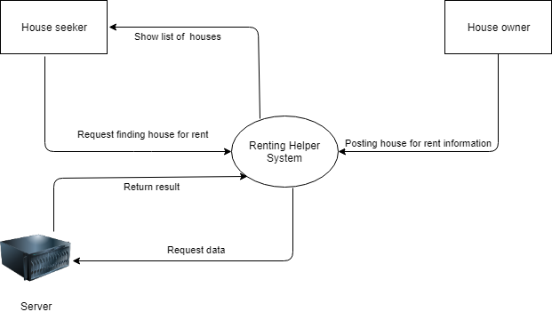

*Figure 2.1: Context Diagram*

#### System context description

User has responsibilities to:

* Find renting house/room
* Post renting house/room
* View renting house/room’s details
* Contact house owner by supplied phone number
* Rate marks

### Technical constraints

#### Technical to develop the system

* Programing language: Java (Android).
* Web service: .Net API

#### Environment

* Operating system: Android
* Develop tools: Android Studio, Genymotion, Visual Studio, Trello
* Manage source code tools: Gitlab.
* Internet Connection.

#### Other constraints

* Resource: 5 people.
* Budget: Limited.
* Time: The project must be completed within 2 months frame.
* Technology: Java, C# .Net language, Google Map API, Heroku, AWS S3.

# MASTER PLAN

## Scrum definition

Scrum is a subset of Agile and one of the most popular process frameworks for implementing Agile. It is an iterative software development model used to manage complex software and product development. Fixed-length iterations, called sprints lasting one to two weeks long, allow the team to ship software on a regular cadence. At the end of each sprint, stakeholders and team members meet to plan next steps.

### Scrum description

There are three specific roles in Scrum:

**Product Owner:** The Product Owner focuses on business and market requirements, prioritizing all the work that needs to be done. He or she builds and manages the backlog, provides guidance on which features to ship next, and interacts with the team and other stakeholders to make sure everyone understands the items in the product backlog. The Product Owner is not a project manager. Instead of managing the status and progress, his or her job is to motivate the team with a goal and vision.

**Scrum Master:** Often considered the coach for the team, the Scrum Master helps the team do their best possible work. This means organizing meetings, dealing with roadblocks and challenges, and working with the Product Owner to ensure the product backlog is ready for the next sprint. The Scrum Master also makes sure the team follows the Scrum process. He or she doesn’t have authority over the team members, but he or she does have authority over the process. For example, the Scrum Master can’t tell someone what to do, but could propose a new sprint cadence.

**Teams working at scrum:** The Scrum Team is comprised of five to seven members. Everyone on the project works together, helps each other, and shares a deep sense of camaraderie. Unlike traditional development teams, there are not distinct roles like programmer, designer, or tester. Everyone completes the set of work together. The Scrum Team owns the plan for each sprint; they anticipate how much work they can complete in each iteration.

### The artifacts

**Product Backlog**: The Product Owner and Scrum Team meet to prioritize the items on the product backlog (the work on the product backlog comes from user stories and requirements). The product backlog is not a list of things to be completed, but rather it is a list of all the desired features for the product. The development team then pulls work from the product backlog to complete during each sprint.

**Sprint Backlog**: is a list of functions developed for Sprint; it is determined by Sprint Planning meeting. Sprint Backlog is the functionality is selected from the Product Backlog based on priority levels and the ability of the team to develop.

**Estimation**: In SCRUM, members of the Task Team will be chosen by yourself and estimate the expected development time and responsible for this estimate. After completing the table will update Sprint Backlog.

### Process

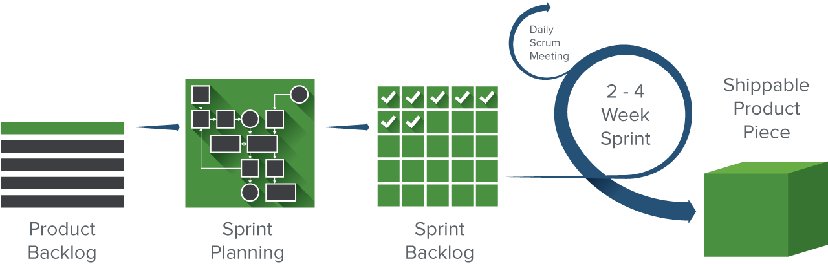

*Figure 3.1: Scrum process*

## Master plan

*Table 3.1: Master Plan*

|  |  |  |  |  |
| --- | --- | --- | --- | --- |
| **No.** | **Task Name** | **Duration** | **Start** | **Finish** |
| 1 | **Initial** | **3 days** | **01-Feb-2018** | **03-Feb-2018** |
| 1.1 | Gathering Requirement | 2 days | 01-Feb-2018 | 02-Feb-2018 |
| 1.2 | Create Proposal Document | 1 day | 03-Feb-2018 | 03-Feb-2018 |
| 2 | **Start Up** | **6 days** | **04-Feb-2018** | **10-Feb-2018** |
| 2.1 | Project Kick-off Meeting | 1 day | 04-Feb-2018 | 04-Feb-2018 |
| 2.2 | Create Document | 5 days | 05-Feb-2018 | 10-Feb-2018 |
| 3 | **Development** | **28 days** | **11-Feb-2018** | **11-Mar-2018** |
| 3.1 | Sprint 1 | 14 days | 11-Feb-2018 | 25-Feb-2018 |
| 3.2 | Sprint 2 | 14 days | 26-Feb-2018 | 11-Mar-2018 |
| 4 | **Project’s Retrospective Meeting** | **1 day** | **12-Mar-2018** | **12-Mar-2018** |
| 5 | **Final Release** | **2 days** | **13-Mar-2018** | **14-Mar-2018** |

## Organization management

### Human resources

*Table 3.2: Human Resources*

|  |  |  |
| --- | --- | --- |
| **Roles** | **Responsibilities** | **Participant** |
| Mentor | * Guide on the process. * Monitoring all activities of team. | Thi S. T. TRINH |
| Team Members | * Estimate time to finish task. * Analyze requirements. * Design and gradually improve the design. * Code and Test the application. * Install and implement the functions of system. * Deploy the product. | Vu N. NGUYEN  Thong T. HUA  Thanh V. TRAN  Diep D. T. N. NGUYEN |
| Scrum Master | * Define and analyze the application. * Assign work for team members. * Control and manage team members. * Orientate for team members. * Make sure that the task is completed on time. * Manage risk. * Provide solutions to solve problems. | Hoang L. NGUYEN |

### 

### Non-human resources

*Table 3.3: Non-human resources*

|  |  |  |  |  |  |  |
| --- | --- | --- | --- | --- | --- | --- |
| **ID** | **Item** | **Purpose** | **Critical (Yes/No)** | **Quantity** | **Acceptance Criteria (optional)** | **Target date** |
| 1 | Laptop | Development | Yes | 5 | Intel Core 2 Duo CPU: 2.2 GHz, HDD: 750 GB, RAM: 8G | 01-Feb-2018 |
| 2 | Java, C# .Net | Programing Language | Yes | 1 |  | 01-Feb-2018 |
| 3 | Trello, Android Studio, Visual Studio, AWS account | Tools | Yes | 1 |  | 01-Feb-2018 |
| 4 | Smartphone,  Android version | Android OS | Yes | 4 |  | 01-Feb-2018 |